M3 Software Design Specification (v1.3)

Tom Carruthers <t.carruthers@oceans.ubc.ca>
https://github.com/ICCAT/abft-mse

Developed for ICCAT GBYP 6/1/2017

Table of Contents
1. Introduction and System Overview 3
2. Design Considerations 4
2.1. M3 Assumptions and Dependencies 4
2.2. General Constraints 4
2.3. Goals and Guidelines 4
3. Architectural Strategies 4
4. Policies and Tactics 5
5. Glossary 5
6. Bibliography 6

Introduction and System Overview

A The Modifiable Multistock Model (M3, v1.3) is the estimation model that supports the ICCAT Atlantic Bluefin Tuna Management Strategy Evaluation (ABT-MSE Figure 1)(GBYP 2014). The model is coded with ADMB (v11.5, 64 bit, Windows 10) (Fournier et al. 2012) and compiled using MinGW (Windows 64 bit v4.2.0).

M3 is a fisheries assessment model based on standard equations for age-structured population dynamics (e.g. Quinn and Deriso 1999, Chapter 8). The model uses fishery, tagging and biological data to estimate a number of quantities for both eastern and western stocks of bluefin tuna including abundance, depletion, productivity, age-based movement, recruitment and fishery selectivity.

The intention of M3 is to estimate these quantities under multiple operating model configurations identified in a finalized MSE trial specifications document. For each operating model configuration, the M3 model is fitted to data and output files (MLE, Hessian, and MCMC samples) can then be read into the wider ABT-MSE framework in R for closed-loop simulation testing of various Management Procedures.

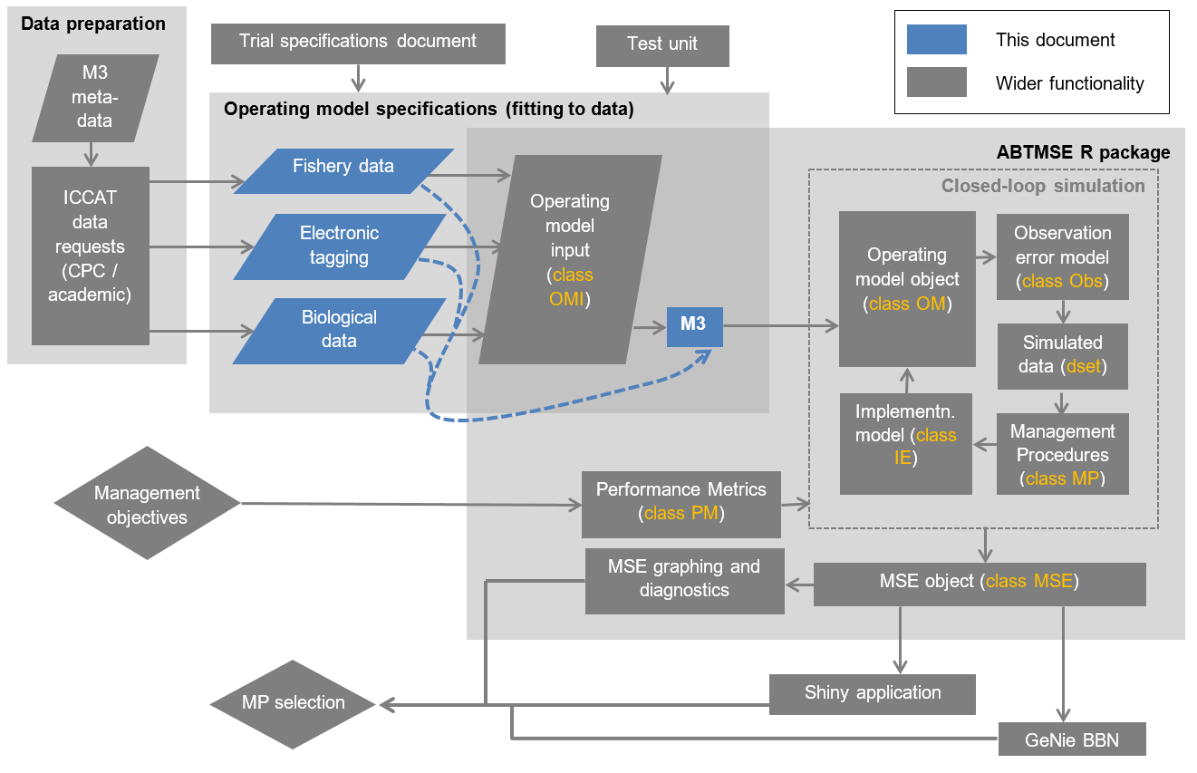
Figure 1. The ABT-MSE framework. M3 components are highlighted in blue. Note that OMI class objects feature in the R package. It is a useful way of organizing data for the M3 model but can be circumvented and M3 data files written directly from data (dashed blue lines).

This document is intended as an overview of the M3 model, its functionality, role in the wider MSE framework, configuration options, design brief and objectives.

Design Considerations

M3 Assumptions and Dependencies

- Dependent on ADMB (v11.5) and a C++ compiler (e.g. MS Visual C++, Borland C++, MinGW).
- Optional I/O from R ABTMSE package.
- Should run in Mac, Linux and Windows operating systems
- Intended for use by quantitative fisheries analysts
- Likely to be branched into assessment and operating model formulations
- Based on conventional stock assessment equations but extended to seasonal spatial structure.

General Constraints

- Estimation should take less than 30 minutes per operating model specification allowing the full estimation of 18 reference set operating models to be completed in less than 1 processor week.
- Must estimate age-based movement
- Must estimate fishery and stock characteristics for Eastern and Western stocks simultaneously.
- Must be based on an established programming language / framework allowing other users to modify code.
- Should be able to produce both maximum likelihood estimates, hessian matrices and Bayesian posterior estimates of model parameters and derived quantities.
- Can be modified to provide a defensible multi-stock assessment of Atlantic Bluefin tuna.
- Can be linked to online data-bases.
- May be validated by simulation testing by an identical simulation model coded in an alternative programming language.
- Should account for historical catches before the current assessment period (ie before 1960).
- Should have the option of fitting to assessment catch rate indices.

Goals and Guidelines

- Since uncertainty is to be primarily captured by alternative operating models, the emphasis is for rapid estimation of any single operating model rather than a single model that is the best representation of the stocks and fishery.
- MLE estimates are the priority, accounting for within model uncertainty using variance-covariance matrix (hessian) or perhaps later, MCMC samples.
- Code should be versatile and easily adapted to accommodate future changes in model assumptions.
- Estimation should be robust (for example should not provide spurious estimates of core parameters given varying initial parameter values)

Architectural Strategies

M3 was coded in ADMB because:

- ADMB is established model development software in fisheries such as Stock Synthesis (Methot and Wetzel 2013), CASAL (Bull et al. 2012), Multifan-CL (Fournier et al. 1998) and iSCAM (Martell 2015).
- there are many quantitative fisheries analysts that have some experience with the software (increasing the chance that code may be developed by others).
- ADMB meets the brief of offering fast robust estimation for high-dimensional estimation problems
- ADMB provides established and easy Bayesian MCMC implementation via the Metropolis-Hastings algorithm
- ADMB is subject to ongoing development (for example parallel processing is in development)
- the template files may be compiled and the executable run, for a range of operating systems (Linux, MacOS, Windows)
- an extensive range of debugging tools are available to support model development in ADMB
- the software is freely available

The M3 model makes use of index table system of data input in which each data point is represented by a line that also includes the indexing of the datum (e.g. year, season, fishery, stock, age). The principal advantage of this approach is that it reduces errors in I/O of high dimensional data (5 dimensions +) and avoids very large input data sets when data are sparse (e.g. 95% missing values).

M3 code is organized into multiple functions allowing a large range of alternative modelling components to be included such as movement models, selectivities, likelihood functions. While the I/O system of ADMB is somewhat clunky in that it requires text files, it has the relative merit that these can be passed among developers and users.

Policies and Tactics

Any version of M3 that is to be used in assessment or conditioning operating models must be (1) subject to simulation testing and (2) released on the private ICCAT GitHub site (ICCAT-GitHub 2016) with sufficient time allowed for experimentation and feedback from others.

An important estimation trade-off is model complexity versus estimation time. M3 makes use of a single master relative abundance index that, along with fleet specific catches, is used to calculation partial fishing mortality rate estimates prior to model fitting. This tactic greatly reduces the number of estimated parameters whilst preserving the same information in relative abundance over time.

M3 is expected to be revised often in light of new model requirements or data availability. New versions are distributed privately (ICCAT GitHub) prior to a public release.

M3 is designed to be run from R (v3.2.3 R Development Core Team 2016) using parallel processing to limit total computation time.

Glossary

ABT – Atlantic Bluefin Tuna
ADMB – Automatic Differentiation Model Builder
Assessment model – A fishery model that represents system dynamics and is used to support management decision making.
Hessian – inverse variance-covariance matrix
I/O – Input / Output
M3 – Modifiable Multi-stock Model, an assessment and operating model for Atlantic Bluefin Tuna.
MCMC – Markov Chain Monte Carlo
MLE – Maximum Likelihood Estimate
MP – Management procedure (an algorithm that takes you from data to a management recommendation)
MSE – Management Strategy Evaluations
Operating model – A simulation model that represents a plausible hypothesis regarding real system dynamics
R – R statistical environment
GitHub – An online repository for computer code

Bibliography

Bull, B., Francis, R.I.C.C, Dunn, A., McKensie, A., Gilbert, D.J., Smith, M.H., Bain, R., Fu, D. 2012. CASAL (C++ algorithmic stock assessment library): CASAL user manual. V2.30-2012/03/21. NIWA Technical Report. 135. 280pp.
Fournier, D.A., Hampton, J., Sibert, J.R. 1998. MULTIFAN-CL: a length-based, age-structured model for fisheries stock assessment, with application to South Pacific albacore, Thunnus alalunga. Can. J. Fish. Aqua. Sci. 55: 2105-2116.
Fournier, D.A., Skaug, H.J., Ancheta, J., Ianelli, J., Magnusson, A., Maunder, M., Nielsen, A. and Sibert, J. 2012. AD Model Builder: using automatic differentiation for statistical inference of highly parameterized complex nonlinear models. Optim. Meth. Soft. 27 (2): 233-249.
GBYP. 2014. ICCAT Atlantic wide research programme for Bluefin Tuna. Available online at: http://www.iccat.int/GBYP/en/index.htm [accessed October 2014]
ICCAT-GitHub. 2016. ICCAT MSE for Atlantic Bluefin. https://github.com/ICCAT/abft-mse.
Martell, S. 2015. The iSCAM project. Available at: https://code.google.com/p/iscam-project/ [accessed 9/9/2015]
Methot, R.D. and Wetzel, C.R. 2013. Stock synthesis: a biological and statistical framework for fish stock assessment and fishery management. Fish. Res. 142: 86-99.
Quinn, T.J., Deriso, R.B. 1999. Quantitative fish dynamics. Oxford University Press, New York.
R Development Core Team (2016), R: A Language and Environment for Statistical Computing. Vienna, Austria : the R Foundation for Statistical Computing. ISBN: 3-900051-07-0. Available online at http://www.R-project.org/.

